**CPSC-1030 Term Project**

**Project Design**

**Web Site Description/Objective:**

* Grocery Store Website
* Duel Interface: Customer/User(Admin & Manager & Employee)
* Animated Background Image for Customer Interface

**HTML5 and CSS Techniques:**

1. An appropriate sub-folder organization for the web-site

* project (folder)
  + guest (folder)
    - index.html
    - login.html
    - recipt.html
    - stylesheet.css
    - sitemap.html
  + user (folder)
    - index.html
    - info.html
    - invoice.html
    - timetable.html
    - employee.html
    - equipment.html
    - stylesheet.css
    - sitemap.html

1. Appropriate multiple column design using CSS

* Two Column Design for User Interface
* Possible Additional Columns for News & Advertisement For Customer Interface

1. External Style Sheets for consistent look and feel for the web site

* Shared “stylesheet.css” for consistent overall look of website, possibly splitting into two style sheet to create two different scenes for Customer& User Interface

1. Navigation menus or bars, created as a semantic list, with either text or icon button simulation.

* Navigation Bar: Text Block

1. A web site map created with a graphics program 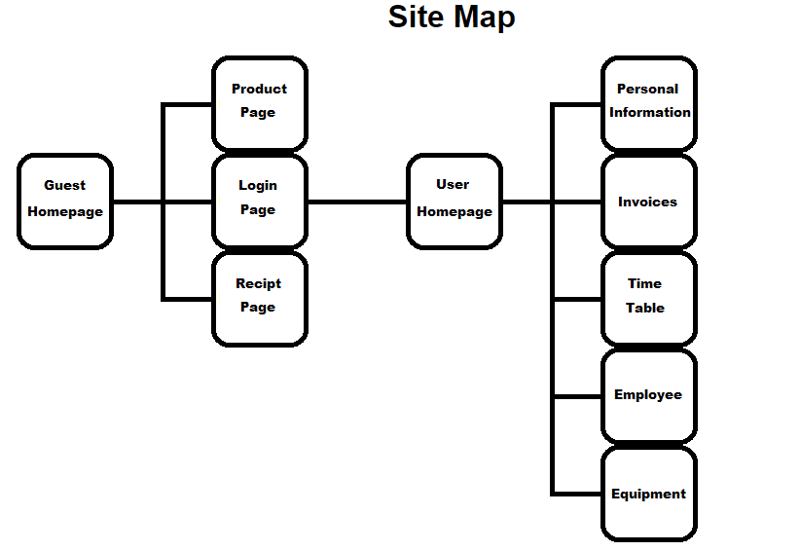

1. An about us page that includes email capability to both the owner of the site and the web site developer (in case of problems to report).

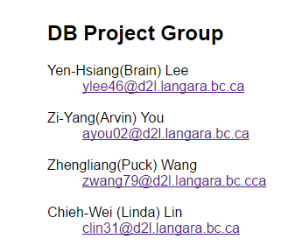

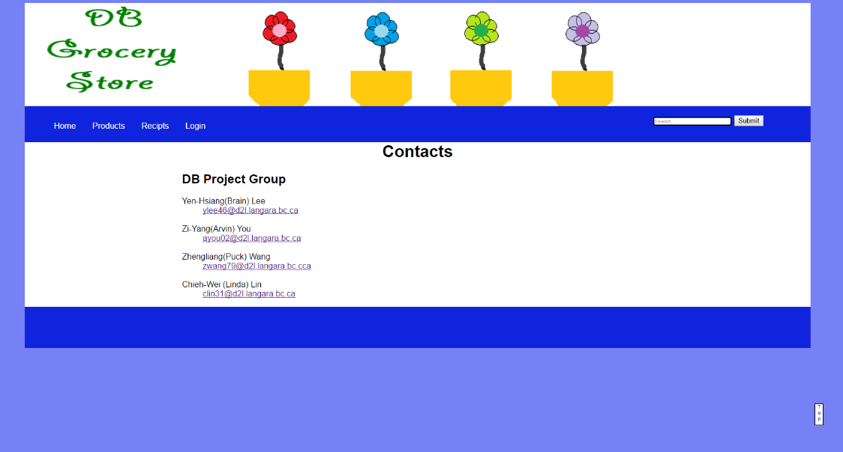

1. One page that features internal navigation through the use of fragment ids.
2. One page that features information formatted in an HTML table (Ch 8).

